Project Proposal: CS/AI Interactive Learning Lab (KnowCS) [Draft]
Student: Zhang Jiahao (Charles) | Student ID: 21121168
Advisor: Prof. Desmond Tsoi
Course Code: COMP 4971B (Independent Work)
Project Link: https://knowcs.pinit.eth.link

1. Project Overview
This project involves the development of "KnowCS," an interactive web-based platform specifically designed for the HKUST COMP 2211 (Introduction to Artificial Intelligence) course. With modern web technologies, the project aims to transform abstract computer science and artificial intelligence concepts into intuitive, interactive visual experiments. The goal is to facilitate a "learning-by-doing" approach, helping students deepen their understanding of complex models through direct engagement.
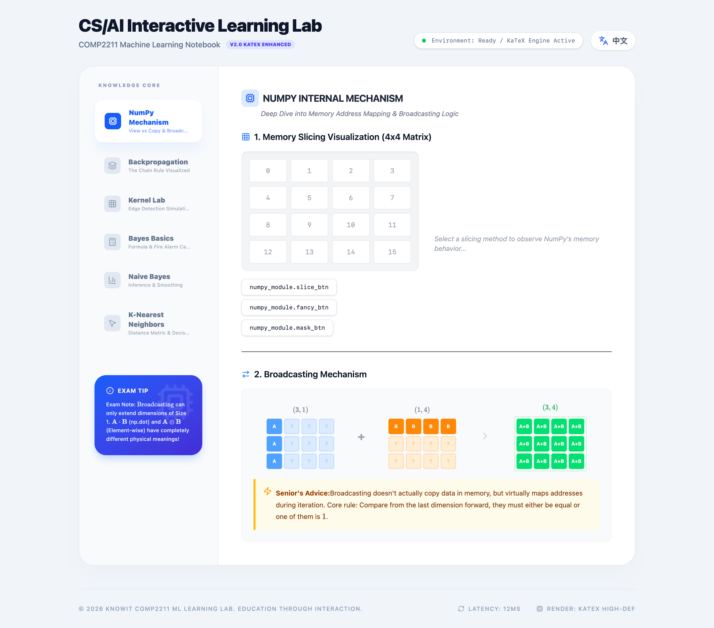

2. Project Objectives
The primary objective is to evolve the project from a collection of "web widgets" into a comprehensive Interactive Learning System. This platform will serve as a "Dynamic Lab Manual" for COMP 2211. When students encounter abstract formulas in linear algebra, clustering, or neural networks, they can access corresponding modules to perform hands-on operations. Through this "What You See Is What You Get" (WYSIWYG) interaction, static lecture notes are transformed into experiments where students can adjust parameters in real-time to observe algorithmic changes and grasp the underlying mathematical logic of AI.
Technically, I am exploring the implementation of a "ready-to-use" Python online runtime environment directly within the browser. The intent is to allow students to experience the actual "model training" process rather than just viewing static results. Users will be able to observe (and potentially train) simple Large Language Models (LLMs) or Image Recognition models, witnessing how a model evolves from "zero knowledge" to successfully recognizing digits or generating text.
In the long term, KnowCS is envisioned as a centralized hub for AI/CS extended learning resources and general academic tools. Planned integrations include interactive interpretations of classic papers, Manim mathematical animations, and Netron model topology analysis. By bridging with the "Knowit" project, KnowCS aims to become a cross-disciplinary resource center, fostering a sustainable, community-driven teaching model that can eventually be extended to other foundational courses such as COMP 1023.

3. Technical Stack
The project utilizes React.js and Tailwind CSS for responsive design, with Vite as the web build tool. Deployment is managed via IPFS for decentralized hosting (currently at knowcs.pinit.eth.link). Interactive logic is handled by JavaScript/TypeScript, while I explore WebAssembly (WASM) and FastAPI for real-time server-side or client-side computation. Additional explorations include JupyterLite for in-browser Python execution and OpenClaw integration.
Category | Technology
Frontend | React v19, Vite, Tailwind CSS v4
Backend | FastAPI (Python), Uvicorn
Animation | Framer Motion
Deployment | Docker, IPFS/ENS (Decentralized), Tencent Cloud
UI/UX & Tools | KaTeX, Manim (Video Generation), Lucide React

4. Proposed Features & Technical Implementation
The project will align closely with the COMP 2211 syllabus [https://course.cse.ust.hk/comp2211/], with modules developed systematically to cover clustering, Naive Bayes, backpropagation, gradient descent, KNN, and NumPy operations. Beyond these core modules, I plan to develop an automated video subtitle script to enhance the accessibility of lecture recordings. If feasible, the system will also incorporate Netron-style network architecture analysis and Manim-based educational videos for distribution on platforms like YouTube and Bilibili.
To foster a deeper learning community, I will establish an AI technical blog to document development insights and challenges. A dedicated Classic AI Papers section is also planned to visualize landmark research such as Attention is All You Need, ResNet, and the DeepSeek-V3 Technology Report. This module will focus on modularizing complex formulas and making paper concepts intuitive through interactive interfaces. Additionally, the platform will explore HKUST authentication and automated synchronization with official course resources, transitioning KnowCS from an independent tool into a professional laboratory prototype.

5. Roadmap
The implementation plan is synchronized with the pace of the Spring 2026 academic semester to ensure maximum relevance for students.
February (Kickoff & Proposal) The initial phase focuses on in-depth requirement analysis and Office Hour consultations with Professor Desmond Tsoi to align project goals. I will finalize the formal Proposal, construct core functional Demos (such as the Convolution Lab), and submit applications for GPU research resources to support advanced model training features.
March : Pre-Midterm Development Efforts will be concentrated on developing the introduction pages and the core content required for the midterm syllabus. During this period, I will release an online user survey to collect student feedback, which will serve as the baseline for refining the system's interface and functionality.
Post-Midterm: KnowCS will officially launch in its Beta version for student testing. Following the launch, the system will undergo iterative updates based on user feedback and the advancing course syllabus.
End of Term: The final stage involves a comprehensive iteration of the platform and the submission of the Independent Research Report. If the implementation proves successful, I will explore expanding the framework's scope beyond COMP 2211 to other foundational courses like COMP 1023, ultimately building a robust, teacher-student driven learning ecosystem.

References
- React (v19) - Used for building user interfaces.
- Vite - Provides extremely fast development server and build experience.
- Tailwind CSS (v4) - Utility-first CSS framework for rapidly building modern UIs.
- Framer Motion - Implements smooth interactive animation effects (e.g., gradient descent tracking, matrix transformation).
- KaTeX - High-performance LaTeX formula rendering library.
- react-i18next - Supports one-click switching between Chinese and English.
- Lucide React - Clean and beautiful icon components.
- vite-plugin-singlefile - Packages the entire application into a single HTML file for easy distribution and deployment.
- Mo Yunxiang Comp2211 Note
- Community Resources: COMP2211 Website
- python-beginners-guide-to-artificial-intelligen https://groupdocs.vip/reviews/E146G7/315026/4983933-python-beginners-guide-to-artificial-intelligence

